21.102: a) 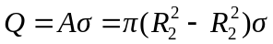

b) Recall the electric field of a disk, Eq. (21.11): 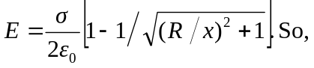
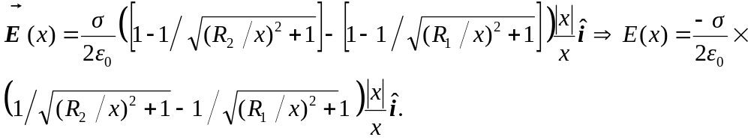
c) Note that 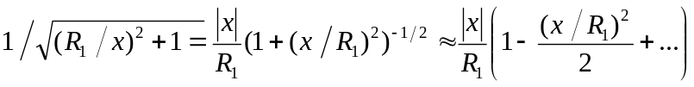
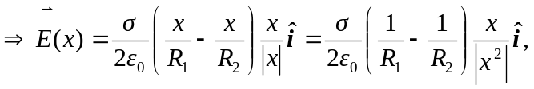 and sufficiently close means that 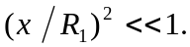
d) 